Hi Sunny –

Thanks for implementing everything! All good on the annotations – they’re not that important but I appreciate you looking into it.

The web links work well. I upgraded pythonanywhere, so we shouldn’t have any issues there. I have typed up a list of further modifications… I think with the implementation of these, we will be just about if not fully done with everything.

1 – Godzilla Tooltip

I noticed that the tooltip feature isn’t active on the Godzilla vs Kong animated chart. Can this be activated please?

2 – Start dates for each chart

I exported replacement CSV files for the charts. I did so because I’d like to control the start date for each chart a little more precisely. You’ll see that in the new CSV files all the data for the first two dates is 0. This was deliberate… I think it will make for a nice effect on the chart if there are no dots when the animation first begins and then a couple days in… they appear. I think the suddenness of it will be impactful.

3 – Enlarging the dots

I was going to ask if its possible to enlarge the size of the dots a bit… but instead, can we add the feature from the amcharts demo where the user can toggle the max dot size? (see image below)

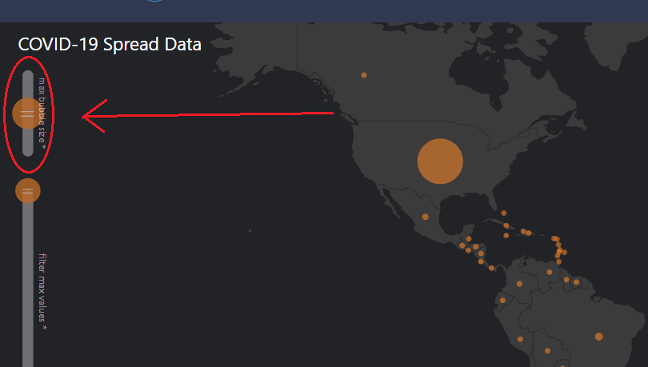

4 – Can we speed up the animation at all?

Im curious, are we able to speed up the animation of the chart? If we can, I wouldn’t want to speed it up too much… maybe 25% faster or so.

5 – Can the font for “Total Downloads” be enlarged, and can the placement be moved?

I’m wondering if we can move it to the top right (just under the map/globe toggle) so that it will be more noticeable. Also, curious if we can enlarge the font a little bit.

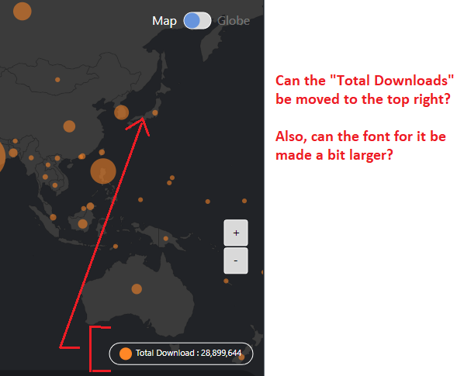

6 – Default zoom of line charts

Can the default zoom of each line chart be?

Wonder Woman 1984: December 16 – Jan 6

GodZilla vs Kong: March 23 – April 6

7 – Can the charts be rearranged?

Can the order of the charts on the pages be rearrange into the following order:

1. Line graph
2. Table
3. Animated chart

8 – Zing Grid table

As you can see in #7, I have referenced a new chart for each movie named Table. This will be a zinggrid table just like what we implemented in the finance section of the site.

I have included a CSV file named: “wonder_woman_grid.csv” – this will be the data that comprises the grid for that movie.

I will need to send you the CSV file for GodZilla vs Kong tomorrow as I am still working on that one. But just a heads up that both movies will have tables of identical format.

9 – Changing title to Wonder Woman 1984

Can the three places where the charts currently say “Wonder Woman” please be changed to “Wonder Woman 1984”?

10 – Image poster and description

I have included descriptons to both movies below. Are we able to format the HTML of each landing page so that there’s an intro section that includes both the description and the movie poster (also included)?

I’ve included a mockup of what that could look like below:

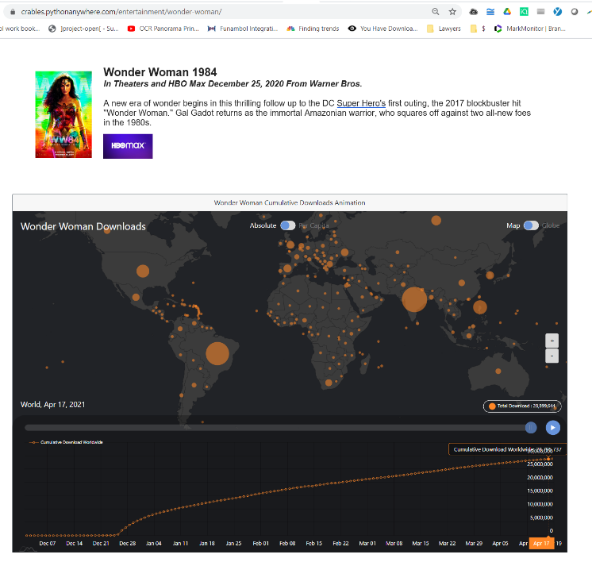

**Godzilla VS. Kong**

***In Theaters and HBO Max March 31, 2021 From Warner Bros.***

Pictures and Legendary Pictures comes the long-awaited face-off between two icons in the epic adventure “Godzilla vs. Kong,” directed by Adam Wingard. Legends collide in “Godzilla vs. Kong” as these mythic adversaries meet in a spectacular battle for the ages, with the fate of the world hanging in the balance.

**Wonder Woman 1984**

***In Theaters and HBO Max December 25, 2020 From Warner Bros.***

A new era of wonder begins in this thrilling follow up to the DC Super Hero's first outing, the 2017 blockbuster hit ''Wonder Woman.'' Gal Gadot returns as the immortal Amazonian warrior, who squares off against two all-new foes in the 1980s.